[This question paper contains ***two*** printed pages]

**BSc(IT)/2021/I/F/ITP102/I Student No:………………**

**Semester End Examination, Spring 2021**

**Royal University of Bhutan**

**Gyalpozhing College of Information Technology**

**BSc in Information Technology - Year I, Semester II**

**ITP102: Object Oriented Programming Fundamentals**

**Time: 3 Hours Max. Marks: 50**

*Write your student number on the top immediately on receipt of this question paper. All questions are compulsory, and marks are given at the end of each question. Parts of a question should be answered together. Spend the first 10 minutes in reading the questions.*

PART A [**5 Marks]**

*Multiple Choice Questions*

1. A computer comprises CPU, Motherboard, RAM, etc. The CPU is the overall functioning of all the above-mentioned components. Choose the one which shows the highest level of abstraction.
   1. RAM
   2. Motherboard
   3. Computer
   4. CPU
2. What value is placed in value?

* 1. 44
  2. 33
  3. 0
  4. 55

1. What are the relationships between the below-mentioned classes?

Vehicle, Suzuki, Hyundai

* 1. All three are super classes
  2. All three are sub classes
  3. Suzuki is the super class, Vehicle and Hyundai are the subclass of Suzuki.
  4. Vehicle is the super class, Suzuki and Hyundai are the sub class of Vehicle

1. What is the output of the given code?

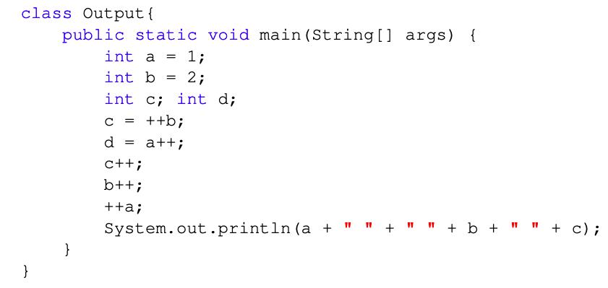

* 1. 3 4 4
  2. 2 4 4
  3. 3 3 4
  4. 2 3 4

1. When using the Scanner class to read data from the console, in order to read data which is an int and assign it directly to an int variable you can use the method:
   1. int()
   2. nextLine()
   3. nextInt()
   4. hasNextInt()

PART B [**5 Marks]**

*Short Answers Questions*

1. What is Error in Java. Give an Example **[2]**
2. What is Encapsulation in Java. Explain how Java achieves Encapsulation Principle **[2]**

PART C